How To Connect Azure Sql Database To POWER BI?

-> to use azure sql database in power bi , we have to connect to azure sql database by our credentials.

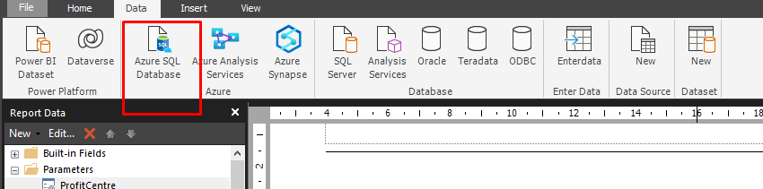

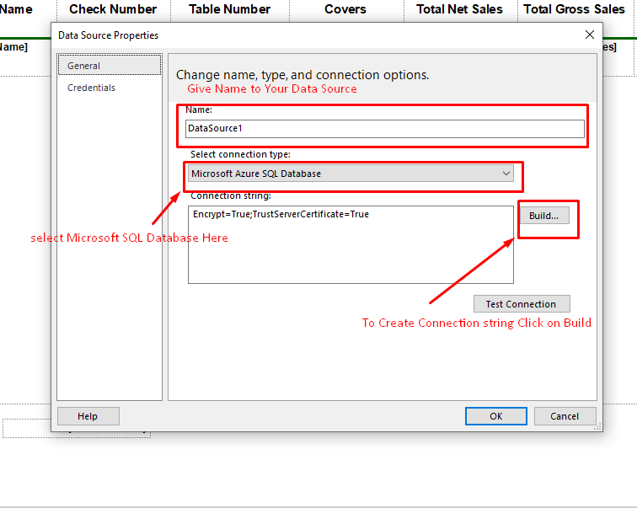

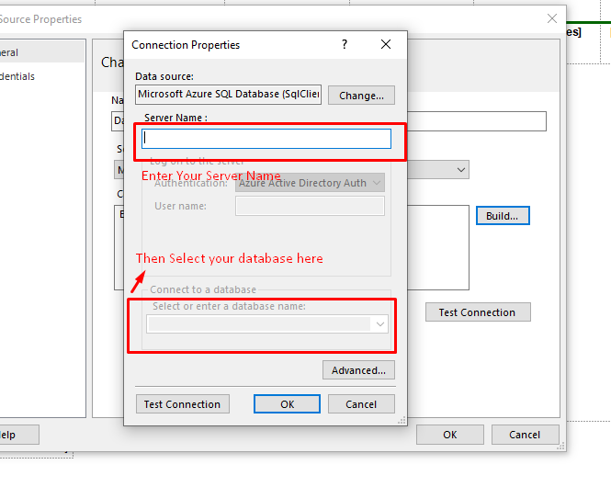

After Successfully Creating Connection Now you are able to use your Azure Sql Database.

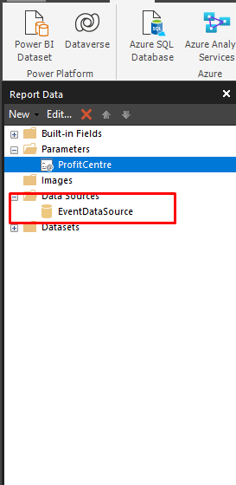

You can see you data source here.

Important Notes:

-> When you connect your power bi to your local SQL Server Database, your Can not publish it to your POWER BI Service.

--> if you want to publish your report to power bi service then your DB Must be on cloud or you have to use gateways or any other ways.